**Creating Domain Name**

1. Request for Certificates in AWS Certificate Manager
2. Add CNAME name and CNAME value in Route53
3. Create application domain name in Route53 using CNAME and map the Loadbalancer DNS name.

Here are the screenshots

1. LoadBalancer configuration

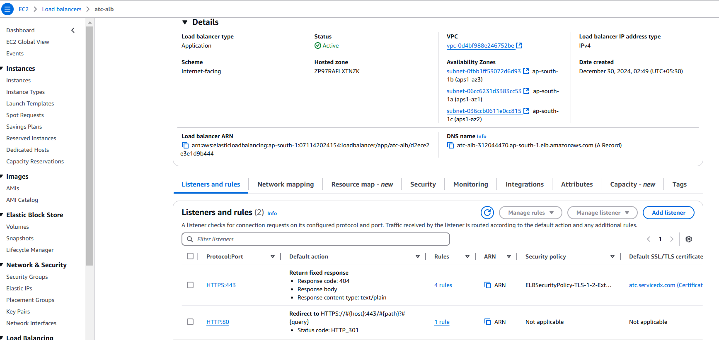

1. Certificates Configuration

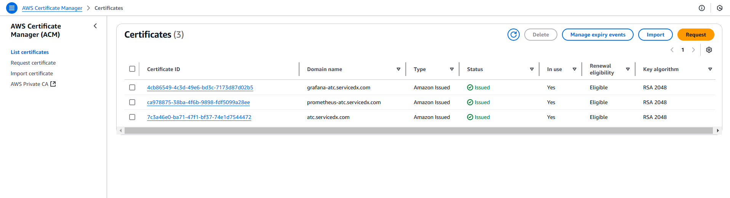

1. Route53 Configuration

